Lesson 4 by: Drs. Rita Littrell & Rogelio Garcia-Contreras

Alternatives: Achieving Desired Outcomes

FOCUS:
Overview:
In the activity, students work in groups to research and think deeply about the allocation of limited productive resources. What are rights of humanity? If clean water is a right, then do we channel resources to provide it? And if we do provide clean water, what is the opportunity cost. After researching issues such as population, education, hunger, potable water, credit, health care and infrastructure, students will have a Socratic discussion about the benefits of these policies and the challenges of providing them. They will do a costs/benefits analysis of providing water or health care. Again, there is no correct or best answer. The use of these tools are situation specific and are often dependent on the details and unintended consequences of policies.

Objectives:
- Learn about challenges and successes of economic development factors
- Learn to do a costs/benefits analysis to compare programs

Essential Question:
What is development? What constitutes economic prosperity? How can we define human security? What is the role of the state in providing a solution to the challenges posted by our economic model?

Background Information:
This lesson offers students the possibility to reflect on the complexities of development, and the way in which state governments are being forced to think beyond the well-being of their own populations. Aspects related to the principles of human Development and their implications on what is known as human security are discussed in this lesson. Today, most governments are overwhelmed by the magnitude of the problems and challenges faced by the majority of their constituents. Poverty, immigration, environmental degradation, global warming, unemployment, human rights violations are all afflictions going beyond the capacity, resources and territorial borders of modern nation-states, adding to the already pressing set of obligations and responsibilities, including of course health care, education or access to potable water.

The future of humanity resides in our ability to shape our current state of affairs into a new and renovated free market, one that is based on a more sustainable relationship between the economy and human beings. Capitalism with a human face, a new set of principles for a brand-new set of investors. A sort of new entrepreneur identifying business opportunities in major social or environmental challenges, investing in these opportunities, and measuring the return of their investment not only in financial terms but in terms of the social or environmental impact this investment has to offer to himself, to his love ones, to his fellow citizens and to the world.

Changing the problems and shortcomings of the free market economy requires a cultural transformation of monumental proportions. This lesson is indeed a new and exciting opportunity to learn alternative approaches to the market economy and the role the state should play in its administration. More specifically, this lesson will introduce students to the alternative postulates of vanguard economists like Manfred Max-Neef or Riane Eisler.

Students will have the opportunity to read extracts from Riane Eisler, whose proposal is a simple yet revolutionary idea first published in her book The Real Wealth of Nations: We must abandon the logic of Economics of Domination, Eisler claims. Throughout history we have justified all kinds of abuses and atrocities in order to control and exploit every resource available to us – including of course environmental and human resources. Instead, we should substitute this perverse approach to the market economy for what Eisler calls Caring Economics, an economic model where parenthood, childcare and education are prioritized for the promotion and procurement of tolerance, respect and fairness, along with the new economic variables that will account for the real cost (and value) of such activities (Eisler, 2000).

The lesson will offer as well the opportunity to learn and discuss Manfred Max-Neef’s six postulates to confront the challenges of today’s market economy:
1. The economy is to serve the people and not the people to serve the economy.
2. Development is about people and not about objects.
3. Growth is not the same as development, and development does not
necessarily require growth.
4. No economy is possible in the absence of ecosystem services.
5. The economy is a subsystem of a larger finite system, the biosphere, hence permanent growth is impossible.
And the fundamental value to sustain a new economy should be that no economic interest, under no circumstance, can be above the reverence of life (Max-Neef, 2010).

The idea is to provide students with a whole new framework to think about the problems that affect us all, in a more creative and inclusive way. The purpose of the lesson should not be to advocate in favor of a particular ideology or approach, but simply to present true alternatives to predominant models, in order to achieve one central learning objective: In this lesson, it is imperative to understand that development is not growth.

Time Frame: 2 class periods

PREPARE:
Materials:
- One copy of Handout 4.1 Issues Cards cut into the individual issue cards.
- One copy of Handout 4.2 Development Issues Research for each group.
- One copy of Handout 4.3 Costs/Benefits Analysis for each group.

TEACH:
Introduction:
Explain that students have been learning about factors that can create wealth and improve the well-being of many humans, including those in poverty. Now students will work in groups to research and learn about the benefits and challenges of these institutions or policies.
Optional: Show one of these videos:
- The Causes of Poverty – By CompelMedia – A 10 minute version of causes of poverty and issues related to it.
https://www.youtube.com/watch?v=Q9QwAPSsE4Y&list=PLJktDoRmRY2ZHO2sVd20M5EHWI1mDAy2h&index=4
- How can countries measure well-being of their citizens? – TED Institute – a 2.5 minute video showing how to measure well-being and a few examples of countries who have made significant changes.
https://www.youtube.com/watch?v=4PkD4JebMAY
- The economics of human well-being – Jan-Emmanuel De Neve – TEDxINSEAD – a fifteen minute video on multiple indicators of well-being and their benefits compared to traditional measurement tools used by economists.
https://www.youtube.com/watch?v=DV1ks-TLYoM
- Building a Caring Economy – Riane Eisler - TEDx Talks – a 25 minute overview of her new book, The Real Wealth of Nations: Creating a Caring Economics. This would be interesting for the teacher or students wanting more depth.
https://www.youtube.com/watch?v=f9cMcTWWDkU

Procedures:
Day 1:
- Divide students into groups of three to five resulting in eight groups.
- Provide each group one of the Issue Cards from Handout 4.1.
- Allow students to research these topics in order to find answers and form opinions for the questions. Remind them to be prepared to defend their opinions. Recommended time is one class period for the research.
- Have students use Handout 4.2 to summarize their research and conclusions to present to their classmates.
Day 2:
- Conduct a discussion using Socratic Teaching, asking probing questions that will generate more questions and deep reasoning.
- Example of Socratic questions that can be asked by the teacher or other students.
  - If you recommend providing potable water to every village because it is a human right, how are we going to pay for it?
  - How do we guarantee that it reaches everyone?
  - Where do we begin?
  - Do the benefits include undocumented immigrants? What grants the right? Must you be a citizen? Or does the fact that you are human mean you have a right to it?
  - Is the answer an economic one? Or a political answer? Or both?
  - Is this a moral dilemma?
- Tell students that the discussion must be civil. They should not condemn students for their opinions. All discussants should back up their opinions with experiences or knowledge.
- Remind students that they are not necessarily finding a ‘correct’ answer. They are learning the complexity of the issue and opening their minds to possible solutions that may be discovered in the future.

Closure and Assessment:
- Have students work in their groups to complete Handout 4.3 Costs/Benefits Analysis chart. For practice, they have chosen to provide potable water and are giving up health care. Have students list costs, things given up, and benefits, things gained, from the choice. This information is reflective of the content of Socratic discussions.
- For the second half of the chart they should consider two development alternatives of their choosing and make a choice. The one they did not choose is their opportunity cost. Have them list the costs and benefits of this decision. This assessment helps them summarize the important factors to consider in making a policy decision.
- Handout 4.3 can be used as an individual assessment if preferred.

Issue 2: Education
- What in your opinion is the importance of Education?
- In your opinion, is education a right or a privilege? Why?
- What are the risks of an educational system?
Issue 1: Population
- What are the issues associated with large populations?
- What policies do you think are important to reduce or control demographic explosions?
- Do you think programs that limit the number of children are beneficial?

Issue Card
Issue Card
Issue 4: Access to Credit
- What are the benefits of credit?
- Who has access to it?
- What is the institution of micro lending?
- Is it a right or privilege?

Issue 3: Hunger
- How does hunger affect lives of the poor?
- What are the effects of malnutrition?
- Is there enough food in the world?
- Can we get food to hungry people?
- What is wasting and what does it cause?
- In your opinion, is food a right or a privilege? Why?

Issue Card
Issue Card
Issue 5: Health Care
- What is the importance of health care?
- Is it a right or privilege?
Issue 6: Infrastructure
- How could a developed infrastructure such as roads with public transportation, a port, Internet or phones help people?
- How could the building of a dam help people?
- How could a bicycle help a person?
Issue Card
Issue Card
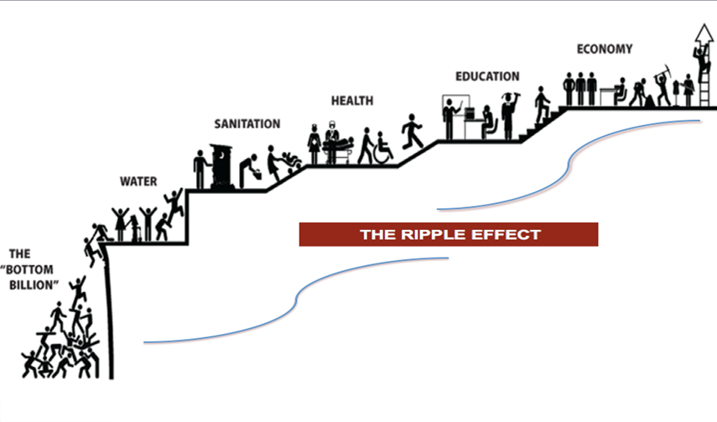
Issue 8: Water
- What are the consequences of not having a clean water source available?
- Is clean water a right or privilege?

Issue7: Money
- What are the consequences of a lack of money?
- Why do people not have money?

Issue Card
Issue Card
Handout 4.2

Development Issue Research

- What is the issue and question on your card?
- What are your opinions on this topic?

- Prepare a presentation to share your question and opinions with your classmates?
- Be prepared to defend you opinions.
- List your sources of information here.

Handout 4.3

Costs/Benefits Analysis

Use this costs/benefits analysis to analyze the decision you would recommend. First, decided to provide potable water to a village but are giving up the opportunity to provide health care. In the second table, you choose which two factors to consider

Choice: Provide potable water – gave up health care
Costs | Benefits
Choice:
Costs | Benefits

Costs: what you give up
Benefits: what you gain
Opportunity Cost: Your next best foregone alternative!

Your opportunity cost of Choice 1: Health care
Your opportunity cost Choice 2:

