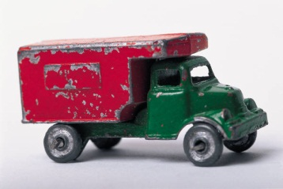**The Wheels on the Truck Go Round and Round**

**Taking Goods to Market**

**Objectives:**

*Students will identify goods as objects/things that people produce that they can touch, feel, and use. (Baseballs, candy, shoes, toys, jeans, and cars are examples of goods. A good is an example of an economic want.)

*Students will identify modes of transportation that are used to get goods to our marketplace.

**Common Core Standards:**

CC.SL.K.5 Presentation of Knowledge and Ideas: Add drawings or other visual displays to descriptions as desired to provide additional details.

CC.SL.1.5 Presentation of Knowledge and Ideas: Add drawings or other visual displays to descriptions when appropriate to clarify ideas, thoughts and feelings.

CC.L.2.5 Vocabulary Acquisition and Use: Demonstrate understanding of figurative language, word relationships and nuances in word meanings.

**Materials:**

*song- The Wheels on the Truck

*Book pattern- Copy one page of each letter to randomly distribute in class

*crayons, markers, colored pencils

**Procedure:**

1. Ask students if they like to shop. (Allow time for students to share responses. Continue the discussion by asking them what they like to buy.)

2. Ask students how they things that they like to buy get to stores and markets in their neighborhoods. (Responses may vary, but many will say by truck, van.)

3. Introduce students to the term “goods”. Tell students that those “things” they like to purchase at the store that they can touch, hold, feel and use are called goods. Goods are some things that satisfy our wants. For example, if I am thirsty, I might want a soda, bottle of water, or bottle of juice. Any of those drinks are goods that could satisfy my thirst. If I am looking for something to entertain me, I might choose a book, game, or basketball. Those also are goods. If I want some clothes, I might consider shorts, jacket, t-shirt, or jeans. If I want a healthy snack, I might choose pretzels, an apple, yogurt, or raisins.)

4. Challenge students to brainstorm a list of goods that satisfy their wants.

5. Explain to students that the goods that consumers like to purchase at the store are brought to the store often by big trucks. (Allow students to share examples of seeing trucks unloading goods when they have been shopping or trucks going by as they are driving.)

6. Introduce the song, “The Wheels on the Truck.”

7. Tell students that today they will be challenged to think of goods that begin with different letters of the alphabet. Randomly distribute a truck pattern to each student in the classroom. The challenge is to brainstorm and illustrate pictures of goods matching the letter of the alphabet received. (Example: If a student has the letter “b”, he or she might draw baseball, banana, book, toy boat, bat, basketball, etc.)

8. Allow students an opportunity to create and illustrate goods for the letter received and time for each to share.

9. Create an alphabet book of goods entitled, “The Wheels on the Truck Go Round and Round Taking Goods to Market.”

10. Share with students that Arkansas has been a leader in the trucking industry. Locate the locations of these companies on a map of Arkansas.

Arkansas trucking companies include:

* J.B. Hunt Transportation – Lowell, AR
* P.A.M. Trucking – Tontitown, AR
* ABF Freight System Inc. – Fort Smith, AR
* Willis Shaw Trucking- Elm Springs, AR
* CalArk – Mabelvale, AR
* USA Trucking, Inc. – Van Buren, AR

Ask students to speculate on why Arkansas would have so many trucking companies? (*Possible answer is central location.*)

Note that Walmart and Tyson Foods operate very large trucking fleets also.

11. Give each student a copy of the truck hand-out included in the lesson. Explain that trucks and buses in other countries are often brightly painted. Show photos included. Have students use the template or create one of their own and design a truck that represents the state of Arkansas. It could have natural scenes for The Natural State. Or it could show the people or the types of goods we produce. Encourage creativity.

C:\Users\amym\AppData\Local\Microsoft\Windows\Temporary Internet Files\Content.IE5\YQ8LUKVZ\MC900310940[1].wmf

**The Wheels on the Truck**

(adapted from *The Wheels on the Bus*)

C:\Users\marsha\AppData\Local\Microsoft\Windows\Temporary Internet Files\Content.IE5\QAINF9L7\MC900310940[1].wmf

The wheels on the truck go round and round,

round and round,

round and round.

The wheels on the truck go round and round

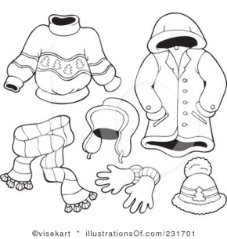Bringing goods to market.

The truck is filled with bats and balls,

C:\Users\marsha\AppData\Local\Microsoft\Windows\Temporary Internet Files\Content.IE5\F6SHM858\MC900435546[1].wmfBooks and shoes,

Clothes and toys.

The market has many goods for sale

C:\Users\marsha\AppData\Local\Microsoft\Windows\Temporary Internet Files\Content.IE5\MBNFYF0V\MC900305637[1].wmfAll for consumers to purchase.

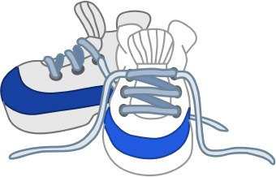

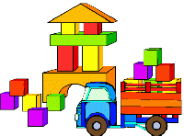

C:\Users\marsha\AppData\Local\Microsoft\Windows\Temporary Internet Files\Content.IE5\QAINF9L7\MC900310940[1].wmf

