Rogers Teacher Honored
Hand-on Approach Earns Smallwood National Award

Rogers Morning News
Thursday, November 24, 2011

Rogers – Learning is full of how, but it’s the why that fascinates Amy Smallwood, a fifth-grade teacher Grace Hill Elementary School.
Her creative lesson plans have won her accolades from her peers and the enthusiasm of her students for the work she does weaving economics into lesson plans.
Economics is not a required subject, but Smallwood says it is the answer to how decisions affect the future and it helps the information students learn in school fit into the real world.
History and children’s literature inspire her lessons. Classroom walls are decorated with life-sized cutouts of characters from the 1939 film “The Wizard of Oz.” One past class project involved a traveling show based on the movie. Students produced and sold goods as part of the project and looked at how decisions made by the characters changed their outcomes.
A quote from Glinda the Good Witch hangs over the interactive whiteboard: “You don’t need to be helped anymore. You have always had the power.” The quote sums up what Smallwood believes economics is all about – decisions.
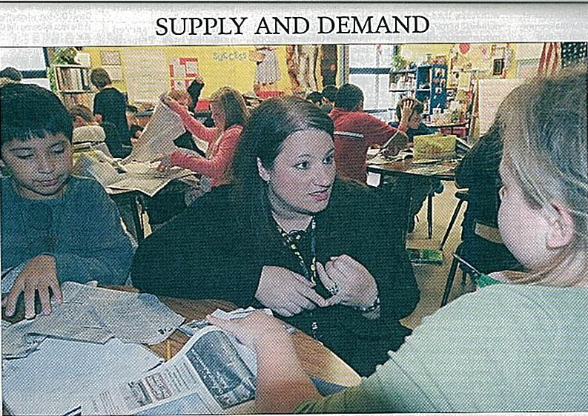

Staff Photo by Flip Putthoff
Amy Smallwood works with students in a lesson on goods and services in her classroom at Grace Hill Elementary School.

“I think economics is the why,” Smallwood said.
Economics is defined as the “science of decision making,” said Melody Key, board member of the Global Association for Teaching of Economics and retired Farmington first-grade teacher.
Key and Smallwood met at summer workshops, and this year Key nominated Smallwood for the Council for Economic Education’s John Morton Excellence in the Teaching of Economics Award. Smallwood was named the national middle school winner in mid-October.
Lesson plans that are original, easy to adapt, carry a home/school connection and that build measureable student work earned her the award, but Smallwood’s acceptance speech was about her students, Key said.
“She talked about her kids,” Key said. “She talked about how she wants them to be successful in life.”
Smallwood has a true passion for the subject matter and is always coming up with new ideas, said Jennie Rehl, Grace Hill principal.
“Amy is such a leader for our school, for our district and really for our state in economics,” Rhel said.
Smallwood taught four years in Eureka Springs as a sixth-grade teacher before arriving at Grace Hill 10 years ago. As a child, she would gather her little sister’s friends in the garage and play teacher.
“It’s the only thing I ever wanted to do,” she said.
Her lessons have earned her fifth-graders’ stamp of approval.
“She makes her stuff fun,” said Megan Billbery, 10.
Ace Edwards, 10, said his teacher is “awesome” and explains things in ways he can understand.
“She makes everything easy for us all,” Edwards said.
Students were gearing up for an economics unit last week by learning the difference between goods and services.
Past class projects also have included opening student bank accounts and planning the Grace Hill book fair by surveying schoolmates on what they wanted to buy.
Last year, the Berlin Wall divided the class for a week with half the class living under the command market structure and half under free market conditions.
Students found benefits on both sides: the East German side had food and the West German side had choices.
“It was a good experience for them to live it,” Smallwood said. “That’s what I try to do is make it real.”
Economics is not just about finance, Smallwood said. Individual decisions make up the global economy and while students learn to talk economics lingo, the true lesson is how to choose what they will be.

