Arkansas Quiz
6.
3.
2.
1.
5.
4.
31.
7.

- From what Indian tribe did Arkansas get its name?
9.
8.
- What does the Latin phrase “Regnat Populus”, our state motto, mean?
11.
10.
- How many stars are there on the Arkansas flag?
12.
- What is our state gem?
- What is our state tree?
13.
- What is our state bird?
14.
- What is our state flower?
30.
15.
- What is our state insect?
16.
- What is our state fruit and vegetable?
17.
- What is our state instrument?
18.
- What is our state beverage?
- What is our state mammal?
19.
- What is our state rock?
20.
- What is our state mineral?
21.
- What is our state American folk dance?
29.
- What is our stat historic cooking vessel?
22.
28.
25.
23.
24.
26.
27.
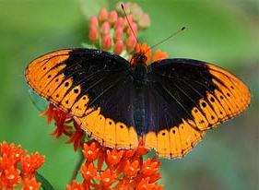
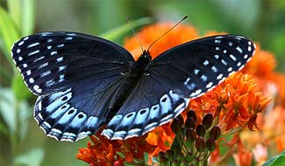

Connect the dots starting at number one; then answer the questions above to see what you have learned about Arkansas in this book.

