Lesson 1 by Drs. Rita Littrell & Rogelio Garcia-Contreras
Choices: Economic Development Factors

Focus:
Overview:
Students learn about factors that affect economic development and rank them according to what they believe to be the most important. They then share their thoughts by standing by the sign of the factor they ranked as most important. The objective is to discuss and learn that the correct answer is situation specific and oftentimes the factors work together.

Essential Question:
What is Development? What is the difference between development and economic growth? Is development needed to achieve higher levels of economic prosperity or should economic prosperity come first as a condition for development? What is the relevance and consequences of aid? Does aid have unintended consequences? What is the relevance and consequences of trade? Does trade have unintended consequences?
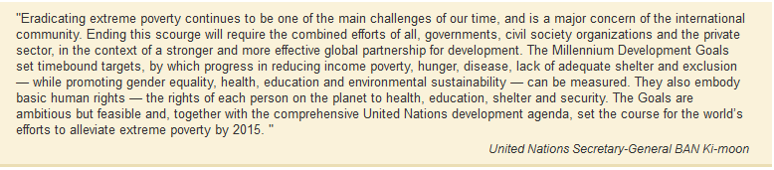

Objectives:
- Learn the meaning of economic development
- Learn and discuss factors that affect economic development

Background Information:
Economic development generally refers to the actions of policymakers and communities that promote the standard of living and economic health of a country, state or community. These actions include development of human capital, development of critical infrastructure, regional competitiveness, environmental sustainability, social inclusion, health, safety, literacy and other initiatives. Successful economic development improves the economic and social well-being of people including under represented populations. Economic growth involves market productivity and increased gross domestic product (GDP) for a country. Economic growth does not consider the distribution of the goods and services produced or the well-being of all sectors of the population. The challenge for economic development policymakers, is to make sure that the dollar invested in a factor of development actually has an impact.

At the Millennium Summit in September 2000 the largest gathering of world leaders in history adopted the UN Millennium Declaration, committing their nations to a new global partnership to reduce extreme poverty and setting out a series of time bound targets, with a deadline of 2015. These goals have become known as the Millennium Development Goals (MDSs). The United Nations includes eight Millennium Development Goals.
1) Goal 1: Eradicate Extreme Hunger and Poverty
2) Goal 2: Achieve Universal Primary Education
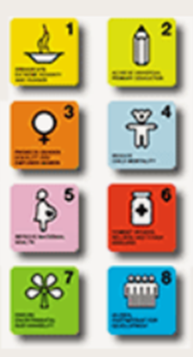
3) Goal 3: Promote Gender Equality and Empower Women
4) Goal 4: Reduce Child Mortality
5) Goal 5: improve Maternal Health
6) Goal 6: Combat HIV/AIDS, Malaria and other diseases
7) Goal 7: Ensure Environmental Sustainability
8) Goal 8: Develop a Global Partnership for Development

Web Resources:
United Nations Millennium Development Goals (MDGs) –
http://www.unmillenniumproject.org/goals/index.htm

Prepare:
- Copy Handout 1.1 Economic Development Factors for each student.
- Print one copy of Economic Development Factor cards on selected color of tag board.
- Place cards around the room on the wall above students’ head height.
- Print one each of the 8 Millennium Development Goal cards on a separate color of paper.
- Locate the YouTube video for viewing in class.
- Distribute Handout 1.1 to each student.

TEACH:
Introduction:
Ask students to think about and describe their daily activities. Discuss school, food, recreation, education, families, games, work, etc. Ask students to discuss what they think a day in the life of youth in countries such as Bolivia, Afghanistan, Ghana, Bangladesh, Somali, Honduras or Indonesia is like. Avoid stereotypes and explain that some children in these countries attend school and live in safe and secure environments but that there are many who are not fortunate to attend school or play with friends because they need to help support their families. Some young people gather fire wood all day or walk miles to carry clean water home. Ask if there are young people in our local community who can’t attend school or who don’t have a home. Along with the discussion, you might want to show one of these videos.
- What is Poverty? By World Vision Australia – A 3 minute video with quiz about definition of poverty. --- https://www.youtube.com/watch?v=tXpm7xDRWk4
- What Causes Poverty? By World Vision Australia – A 3.5 minute comparison of lives of poor and middle class children. https://www.youtube.com/watch?v=SCUhFFQ_ZRA
- How do we Measure Poverty? By World Vision Australia – a 3 minute explanation of the Human Development Index. –
https://www.youtube.com/watch?v=w5wORaWcWPY
- What is Poverty? By Compassion International – 2 minute introduction showing video of lives of poor people. - https://www.youtube.com/watch?v=k-PvTqo1gX0
- Top 35 World’s Poorest Countries 2015/16 by Je Suis Charlie - A 9 minute slide show of life of people around the globe. Includes many types of homes, trash, farming, small business, large numbers of people, lack of school or transportation, and more. ---- https://www.youtube.com/watch?v=WMIlw3Q4Yf8
Conduct a discussion of what students think should be basic rights of every child. These might include safety, love, water, food, shelter, clothing, health care and education.

Optional: Reading Beatrice’s Goat by Page McBrier is a good introduction to a sustainable development model utilized by Heifer International. In this story, Beatrice’s family receives a goat as a gift after learning to care for it. The goat provides nutrition through the milk and then an income as they sell the extra milk. The kids from the goat are given to other families so they can improve their standard of living. The income earned from selling the milk sends Beatrice to school and then helps them to build a house that does not leak. This is based on a true story. Beatrice ended up studying in Arkansas at the University of Arkansas Clinton School of Public Service.

Careful, however, with this kind of success stories. World communities are not the same. Each community is diverse and presents different circumstances and needs. Development policies work better whenever they are customized to a circumstance that is well-known, not only assumed or “understood”.

Procedures:
- Give each student a copy of Handout 1.1 Economic Development Factors.
- Allow ten minutes for students to read the factors and then to rank them according to what they believe would be the most important factor.
- Have students stand beside the card titled with the factor they thought was the most important.
- Allow each group to discuss why they selected this factor as the most important.
- Have one spokesperson from each group share with the class their reasoning.
- After each group has shared, one by one display each of the 8 Millennium Development Goals. Have students decide which factor would encompass each goal. Hand that factor to one of the members of the group. This will not necessarily be a perfect fit. In some cases students will have to decide the best fit for the goal.
- Discuss which factor encompasses the most goals. The students might conclude that the factor with the most goals is the most important. But this is not necessarily the case.
Closure and Assessment:
- Summarize by explaining that there truly is no one best factor. It is dependent upon each country, city or community. And many of the factors work together. Note that world communities are not the same so therefore a cookie-cutter approach does not work the same in each place. Each community has varied resources and needs. Development policies work better when they are customized to the specific needs of that community and built on the available resources. This is why social entrepreneurship can be powerful. These entrepreneurs recognize the needs of the community and use the available resources to provide opportunities that improve the well-being of the people in that community. The approach is integrated into the fabric of the community.
- Explain that their knowledge about factors that affect economic development will be used in an activity tomorrow.

Handout 1.1

Factors that Affect Economic Development
- Education embodies the education and health of the workers. More knowledgeable workers are more productive as are healthy and well fed workers. Education of women has proven to be very effective as they are usually responsible for the health of the family and the family finances.
- Infrastructure is the technical structures that support a society, such as roads, water supply, sewers, electrical grids, dams, production facilities, railroads, waterways, and so forth. It is the physical components needed to provide commodities and services essential to improve living conditions. It provides ways to get information about health, weather and news as well as ways to transport people or goods.
- Health care is critical for well-being and for productive reasons. Workers who have dysentery or AIDS are not very productive at work or home if they can work at all. They are also not able to help with family needs. Healthy workers can contribute to a better quality of life.
- Banking sector supports economic growth. Entrepreneurs, households or businesses need access to capital or money to grow their companies or improve their well-being. Having a banking sector enables saving which results in investment. People in poor communities often lack access to loans that can improve their well-being. An institution known as micro-loans and founded by Mohammad Yunus has been successful in providing small loans to people in poor communities who lack collateral.
- Higher education provides opportunities to learn about and create ways to improve lives and develop communities. It includes research, development and entrepreneurship resulting in new technologies and capital tools that increase productivity or cure diseases.
- Entrepreneurship has proven to be a critical factor in developing new productive capacity. Entrepreneurs use resources to build companies, both for profit and non-profit, and create jobs for other people. Companies and people pay taxes that are used to provide public goods and services. Entrepreneurship is essential to economic development and growth. Local entrepreneurs use available resources to fulfill market needs. Growing your own is highly recommended.
- Trade enables a person to specialize and therefore be more productive. Removing barriers to trade can result in higher incomes for many people. Increased trade may result in some people earning less or losing jobs. This should be recognized and remediated through education and training for the disadvantaged workers.
- Value added goods result in greater revenues in a global market. Commodities have minimal monetary value. Selling coffee, beans or rice to the world market results in price fluctuations and minimal revenues resulting in the farmer often not earning enough to support his/her family. By adding value to a commodity, the revenue stream is increased. As an example, coffee beans bring a very low price but roasting the beans and packaging the coffee brings much more revenue on the world market which results in higher wages for workers. To do this you need the know-how and the capital tools to roast and package the coffee – which is often provided through higher education.
Handout 1.1 continued

Creating a Healthy Community

Task: Prioritize the following items that are critical to economic development.

Education
Infrastructure
Health Care
Banking Sector
Higher Education
Entrepreneurship
Trade
Value Added

Highest Priority

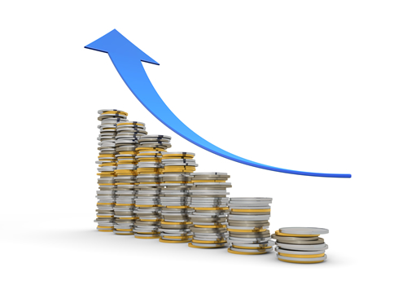
Lowest Priority
Economic Development Factor Card
Education
Infrastructure
Economic Development Factor Card
Health Care
Economic Development Factor Card
Banking
Sector
Economic Development Factor Card
Higher
Education
Economic Development Factor Card
Entrepreneurship
Economic Development Factor Card
Trade
Economic Development Factor Card
Value
Added
Economic Development Factor Card
Millennium Goals
Goal 1:
Eradicate Extreme Hunger and Poverty

Millennium Goals
Goal 2:
Achieve Universal Primary Education
Millennium Goals
Goal 3:
Promote Gender Equality and Empower Women
Millennium Goals
Goal 4:
Reduce Child Mortality
Millennium Goals
Goal 5:
Improve Maternal Health

Millennium Goals
Goal 6:
Combat HIV/AIDS, Malaria and
Other Diseases
Millennium Goals
Goal 7:
Ensure Environmental Sustainability
Millennium Goals
Goal 8:
Develop a Global Partnership for Development

