Off the Shelf . . . with Economics

At the BMCEE we have a whole stash of children’s books that teach economics. For this video series, we plan to take books off the shelf, one at a time, to show to you. You will learn about the educational value of these books as well as the economic concepts that can be taught be reading these books. From time to time, we will have guest readers, so please let us know when you discover a new children’s book that you use to teach economics!
bmcee@walton.uark.edu

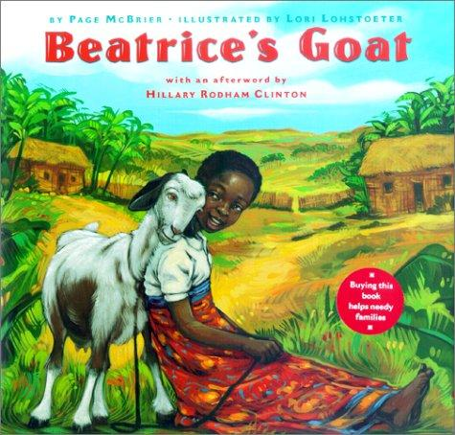

Beatrice’s Goat

Written by Page McBrier
Illustrated by Lori Lohstoeter

More than anything Beatrice wants to be a schoolgirl. She yearned to sit on one of the outdoor benches, figure sums on a small slate chalkboard, and to turn the pages of a worn book. But in her small Ugandan village, only children who can afford uniforms and books can go to school. Beatrice knows that with six children to care for, her family is much too poor. But when Beatrice receives a goat as a gift she names it Mugisa, which means luck. Before Mugisa, Beatrice helped tend the chickens, care for the fields and watch the younger children. Mugisa’s milk provided nutrition which made the family healthier. She was able to sell the extra for income which paid her school fees and other improvements to their lives. One of Mugisa’s kids was given to another family thus passing on the gift. Mugisa was given to the family by Heifer, an international non-profit organization founded by Dan West dedicated to relieving hunger and poverty.

The economics concepts are plentiful. To begin with the family has a scarcity of many things. They need more nutritious food and a house with a roof that will not leak. Beatrice was considering spending the income earned from selling Mugisa’s milk to buy goods for her siblings. But her mother chose to send Beatrice to school where she will receive the service of education. School has many benefits as Beatrice can develop skills which will allow her to get a job in the future. When workers develop skills or become healthier, they are developing their human capital. This book is based on a true story. It shares the mission of Heifer in a true and engaging story. After attending her village school, Beatrice goes to a university in United States and eventually studies at the Clinton School of Public Service.

Additional Resources:

Audio story of Beatrice’s Goat: https://www.youtube.com/watch?v=gT_itGTfulo

The true story of Beatrice Fiira from Heifer site: http://www.heifer.org/join-the-conversation/blog/2011/june/one-of-heifers-greatest-success-stories-beatrice-biira.htmlThe

Sixty Minutes story on Beatrice: http://www.cbsnews.com/news/beatrices-goat-fed-a-dream/

Heifer International Educational Simulation: http://forgefx.com/simulation-projects/heifer-international-serious-game/

National Content Standards in Economics: http://www.councilforeconed.org/ea/standards/ - This resource explains basic economic understandings and states what is important for students K – 12 to learn. It is a very useful for teachers in defining economic terminology.

