Written by Trudi Kepner

Let's Do Lunch!

A Survey of Dining Patterns

FOCUS: (Appetizer)

Overview: Using the restaurant industry as the theme for this unit of study, students analyze the goods and services produced. They investigate the economic impact of restaurants on their community. Students gather data from parents as consumers, identifying their tastes and preferences in restaurant choices. Using the survey results, students construct a bar graph depicting the restaurants most frequently patronized. After identifying the most popular restaurants in their community, students design an invitation asking those restaurant owner-managers to come to the classroom for an interview and discussion about operating this type of business.

Concepts: goods, services, consumer, producer, scarcity,
opportunity cost

Integrate: math, research

PREPARE: (Salad Course)
Materials:
Part One: Phone books (8-10)
Brochures from local Chambers of Commerce with listings of area
restaurants
Favorite Restaurant Graphs Handouts (3 of each)
Chart paper and markers (optional)
Restaurant Preference Quiz Transparency
Restaurant Categories Transparency

Part Two: How May We Serve You? Handout (one per student)
Graphs from Part One

Part Three: Where We Eat Transparency
Where We Eat Handout (one per student)
Food For Thought Handout (one per student)
Chart paper and markers (optional)
Graph paper, one sheet per group
Supplies for student-created invitations (one invitation per
restaurant category)
Consumer Demand Transparency

Construct:
Part One:
1. Collect 8-10 area phone books.
2. From the local Chamber of Commerce or tourist board, collect
brochures or publications advertising restaurants.
3. Duplicate handouts in numbers indicated.
4. Prepare listed transparencies.

Part Two:
1. Duplicate handout.
2. Locate Favorite Restaurant Graphs constructed by students in Part
One. Make transparency of graphs.

Part Three:
1. Prepare transparencies and handouts, as indicated.
2. Collect construction paper, markers, and any other materials
appropriate for construction of an invitation.

TEACH: (Entree)
Part One: Listing and Categorizing Local Restaurants (1 - 2 days)
Introduction: The intent of this lesson is to find out, when given a choice, which restaurants the students prefer to frequent.
1) Begin the lesson with the following oral quiz, with responses written by the students. (When completed, the students will put the quiz off to the side to be used later in this lesson.)
Quiz:
a. List a restaurant you would select when eating dinner with your
family.
b. List a restaurant you would select when eating out with your
friends.
c. List a restaurant you would select when celebrating a birthday.
d. List a restaurant you prefer for breakfast.
e. List a restaurant you prefer for lunch.

2) Ask students to put this quiz to the side.

3) Discuss with the class the restaurants listed on their quizzes. Why is the same restaurant not listed for each situation and for each person in the class? (Tastes and preferences of consumers vary.) What goods and services are provided in restaurants? (prepared food, beverages, table service, seating, atmosphere)

4) List the restaurants from the student quizzes on the chalkboard or on chart paper.

5) Divide the class into groups of 4-5 students per group. Each group needs a phone book and brochures listing restaurants in the community. Use this new information to extend the class restaurant listing.

6) Discuss the characteristics of the various restaurants and have the groups brainstorm categories into which restaurants could be divided. Allow the groups time to categorize or code the restaurants on the list. (Fast food, Midscale and Upscale are common categories used by the foodservice industry.)

7) Ask each group to share their restaurant categories and the characteristics of each. Display the Restaurant Categories Transparency. Discuss and relate the industry category labels with the student-produced categories.

8) After coding all of the categories by “F” for Fast Food, “M” for Midscale and “U” for Upscale, the students will analyze and code their quiz answers placing the appropriate category heading beside each restaurant chosen.

9) From the tallies made in #8 above, have the students determine which category of restaurant they utilize most frequently. Have students write journal entries analyzing restaurant categories from their personal choices. Encourage students to share their reasons for selecting certain restaurants for different occasions.

10) While the students complete their personal journal entries, the teacher compiles the overall class totals by category on the chalkboard or chart paper.

11) Discuss the results of the class list and personal quiz information:

a. Which category of restaurant was most popular for the class?
Which was the favorite for each individual student?
b. Are the restaurants equally distributed across the categories?
If not, why not?
c. Looking at your community, do the kinds of restaurants that
the students indicate as their preferences exist in the numbers
needed to satisfy their wants?
d. Is the category most frequently appearing on their quiz (i.e., fast
food) the same as the category with the greatest number of
restaurants appearing on the board (i.e., fast food)?
e. What new trends have you noticed in the restaurant industry?
("to-go" prepared meals, prepared foods in grocery stores,
carry-out home-style meals)

Note to teacher: During the above discussion, include economic concepts in the dialogue to make the terms familiar to the students -- consumer, producer, demand and others as appropriate. See the Appendix for definitions.

12) Students vote for their favorite restaurant in each category using a secret ballot, the back of their quiz, or whatever you choose. Tally and graph these results as a class. Save this graph for Part Two.

Part Two: Restaurant Services (2 days)
1) Discuss that restaurants, as producers, offer both goods and services. Refer to the graph from Part One of favorite restaurants. Explain that as consumers we make choices based upon the goods and services offered by the restaurants. (Some students liked the product offered while others prefer the services provided by the restaurant.) Emphasize that customers (consumers) choose restaurants in a highly competitive industry based on the goods and services produced, as well as the quality of the product.

2) Divide the class into groups of three to work together on this assignment. Assign each group a restaurant category using the master restaurant list from Part One. (More than one group will be assigned the same category.)

3) Distribute the research sheet How May We Serve You? Each group should list the restaurants from their assigned category across the top. (Since more than one group is assigned to the same category, have each group select different restaurants.) Assign all restaurants from the master list. Have students complete as much information on the How May We Serve You? Handout as possible from their collective experiences. Allow one or two days to do further investigations using phone call interviewing to the restaurants, information from customers, or on-site restaurant visits. Save this research sheet!

Part Three: -- Consumer Profile and Restaurateur Interview
1) When all of the How May We Serve You? research sheets have been completed, discuss the groups’ findings. Examine the variety of services offered to discover a pattern within and between categories. Discuss competition in the restaurant industry and the role services play in attracting customers to a business.

2) Discuss the impact of the restaurant industry on the community. Have students try to imagine their town with no restaurants (or the reverse situation in small towns). Discuss the economic effect on employment, tourism, other businesses, new and existing residents, the construction industry, and the general impact on the economy of the community.

3) For a one- or two-week period, have each student conduct “Refrigerator Research” entitled Where We Eat, creating a profile of a typical consumer of the foodservice industry. Have each student record the data for his/her family or household. Explain the importance of gathering accurate and complete information. Review each column on the data sheet, answering any student questions. Complete a sample entry in class. Review the process for computing the cost per person of the meal in the last column. Include tax and gratuity in the total cost.

4) Send the parent survey Food for Thought home to be completed by the same date as the data collection for Where We Eat.

5) When the “Refrigerator Research” Where We Eat and the Food for Thought sheets have been returned, have students work in groups to compile their restaurant information. Using the “Refrigerator Research” data, groups compile an alphabetical listing of their restaurants. Have students tally the number of breakfasts, lunches, dinners, and snacks per restaurant. Then have the groups list the appropriate category grouping after each restaurant on their list. Example:

Restaurants | Breakfasts | Lunches | Dinners | Snacks | Category
Hardly's Cook | 2 | 4 | 5 | 1 | U
Squat & Gobble | 4 | 2 | 3 |  | M
Hackey Snacks | 6 |  |  |  | FF

6) As a class, compile the group results on the Consumer Demand Transparency to create a class consumer profile. Collect the individual data sheets and surveys for later use in analyzing the total number of consumers per restaurant, average cost of meal per visit, busiest time of the day, etc.

7) When the class consumer profile is complete, analyze the results to determine the most frequently visited restaurant for each meal.

Optional: Assign student groups to construct graphs of the restaurants visited for each meal.

8) Using the Favorite Restaurant Graphs from Part One in this lesson, have student groups design an invitation for the top restaurant in each category. Invite these restaurateurs to the class to share information about their restaurants and to answer student questions.

Assessment: Each student writes a paragraph describing his/her restaurant preferences based on the goods and services provided. In the second paragraph, describe the class preferences. In the third paragraph, compare and contrast these preferences.

CONNECT: (Dessert)
Restaurateur Questions:
1) What type of restaurant do you operate?

2) Which time of day is the busiest?

3) What ages are most of your customers?

Geography: Construct a bulletin board using a local map. Use color-coded pins to indicate restaurant locations according to selected categories (Fast food, Mid-scale, Upscale). Analyze the pin locations in relation to the city's main thoroughfares. Discuss the positive and negative factors of the restaurant locations. Analyze the possible effects of the proximity such as the distance between competitors and the location relative to shopping centers, schools, and entertainment facilities.
Students could create a personal Out to Lunch Map of restaurants using a local map. Each new restaurant visited locally would be added to their own map. This would be an on-going collection of data.

Language Arts: Give students’ restaurant reviews from the newspaper to read. Have them create their own review of their favorite restaurant. Encourage students to use many descriptive words to create vivid images. When the students finish their reviews, mail them to the restaurants, accompanied by a student letter explaining the project and the review process.
These reviews could be included in a class newsletter featuring a Restaurant-of-the-Month. Student research opportunities might include phone interviews, e-mail correspondence, written surveys, or on-site visits. Copies of the newsletter could then be shared with the featured restaurant, parents, and other classes.

Math: Adopt-a-Restaurant Market Analysis -- Assign students, working in pairs, to review the class research sheets for data on a selected restaurant. Have students calculate the average per person cost for each meal. Determine which time of day would be the busiest at this restaurant.
Transparency

Restaurant Preference Quiz

List a restaurant you would select when ...

a. eating dinner with your family.

b. eating out with your friends.

c. celebrating a birthday.

d. going out for breakfast.

e. going out to lunch.
Transparency

Restaurant Categories

Fine Dining

UpScale

Mid-Scale

Fast Food

Carry-Out

Delivery
Handout

Favorite Upscale Restaurant
in (your community)

30
25
20
15
10
5
0

Upscale Restaurants

Create a bar graph showing your class preferences.
Handout

Favorite Mid-Scale Restaurant
in (your community)

30
25
20
15
10
5
0

Mid-Scale Restaurants

Create a bar graph showing your class preferences.
Handout

Favorite Fast Food Restaurant
in (your community)

30
25
20
15
10
5
0

Fast Food Restaurants

Create a bar graph showing your class preferences.
Handout

Favorite Carry-Out Restaurant
in (your community)

30
25
20
15
10
5
0

Carry-Out Restaurants

Create a bar graph showing your class preferences.

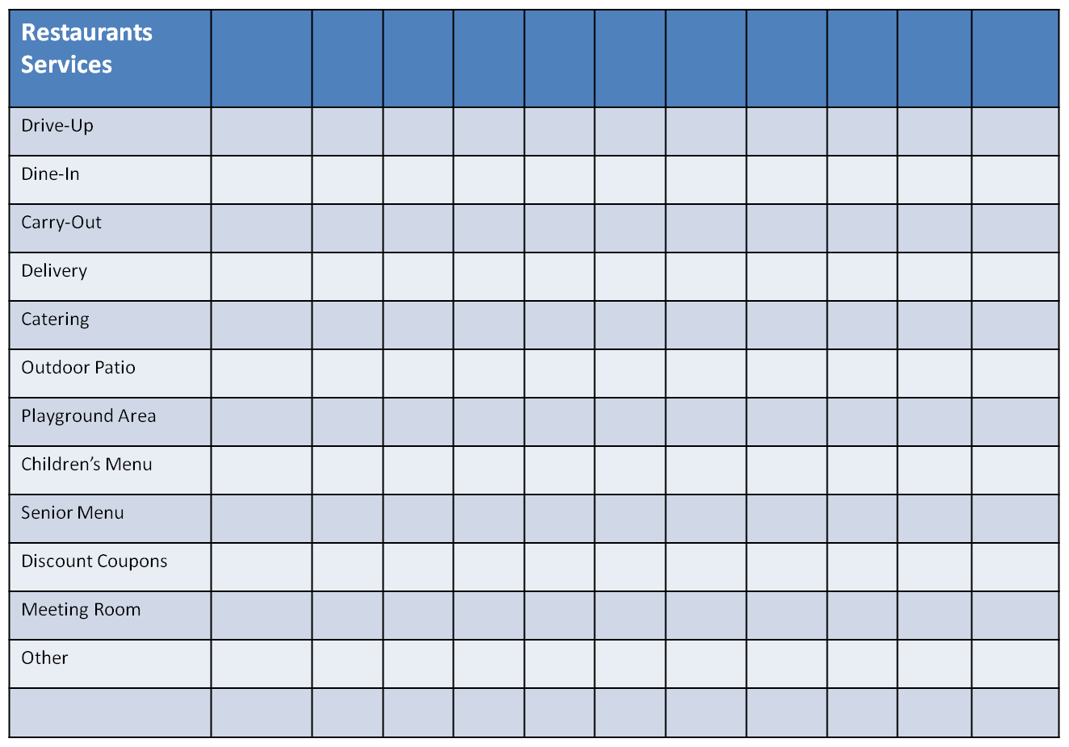

Transparency & Handout

Where We Eat

Name: Dates:
From:
Number in Household: To:

Day  of the  Week | Restaurant  Name | Type* | Meal | Dine in? | # of Persons:  Male/Female/Children | Total  Cost of Meal** | Cost  per  Person
Monday
Tuesday
Wednesday
Thursday
Friday
Saturday
Sunday
Monday
Tuesday
Wednesday
Thursday
Friday
Saturday
Sunday

* Types: Upscale, Mid-Scale, Fast Food
** Include the tax and gratuity.
Handout

Food For Thought

Parent Survey

1) On the average, how often do members of your family go out to eat in a week?
Breakfast Lunch Dinner

2) Which restaurant does your family visit most often?

Why?

What factors affect the choice? (time, cost, food type)

3) Which day of the week does your family most frequently eat out?

4) What amount do you usually spend per person on a meal?

5) Please list several restaurants that your family has visited.
Put a "1" before your first choice, a "2" before your second choice, and a "3" before your third choice of favorite places to eat. (Use other side if necessary.)

Which criteria determine your favorite restaurant? (Check all that apply.)

Food quality Special Features: Drive-through
Food selection Children's Menu
Speed of service Senior Discount
Quality of service Carry-out
Location of restaurant Toys, premiums, special
Price/cost discounts
Outdoor patio
Other

Transparency

Consumer Demand

Restaurants | Breakfast | Lunch | Dinner | Snack | Category
1.

2.

3.

4.

5.

6.

7.

8.

9.

10.

1) Which three restaurants serve the most breakfast meals to this class?

2) Which three restaurants serve the most lunch meals?

3) Which three restaurants serve the most dinner meals?

4) Which three restaurants serve the most snacks?

