**History Map Locator: Part 1 ---Pre-reconstruction**

Find and Label with a Highlighter:

* Draw a tepee where each of the three major Native American Tribes lived in Arkansas. Include the tribe names: Caddo, Quapaw and Osage.
* Write De Soto’s name where he crossed the Mississippi
* Circle the first post of Arkansas, which was established by Henri De Tonti
* The main area where cotton was grown through a plantation-style system. Highlight this region with diagonal lines.
* The area where the Arkansas Peace Society was formed, which was a group of people who opposed the decision to secede from the Union.
* Draw a cannon on places where in the state where major Civil War battles were fought. Arkansas Post, Helena, Pine Bluff, Little Rock, Pea Ridge, and Prairie Grove.
  + Note who won these battles
* The city in southwest Arkansas where the capitol was moved to for a short time when Little Rock fell in a Civil War battle.
* The city that is named after the first governor of Arkansas
* 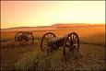In 1821, the territorial government was moved from Arkansas Post to more centrally located ___________. Highlight this site.

**History Summary: PART 1**

The study of Arkansas history is important for a number of reasons. It lets us know where we come from and it helps us learn from our past as we chart our future. Young people can obtain a sense of being part of an ongoing saga and gain a perspective on their place in history. Finally, it is enjoyable to have knowledge of the state and the people who made us what we are.

**Early Inhabitants-** When European explorers came to what is today Arkansas in the 1500’s they found a sizable population. The original people were organized and lived in distinct tribes. Europeans recorded the names of these tribes as Osage, Quapaw, and Caddo.

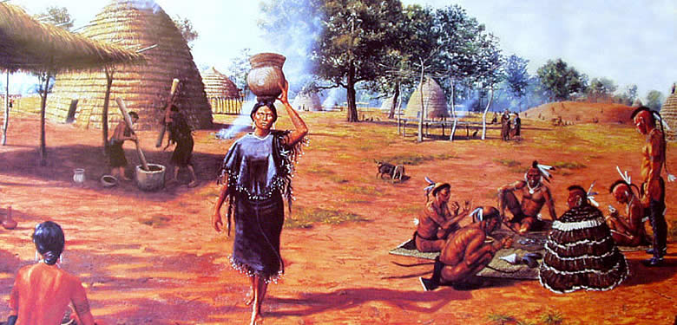

**Caddo**- The Caddo tribes lived in the Red River and Ouachita Valleys of the southwest. They were productive farmers who produced crops of corn, squash, and beans, and participated in some hunting. Their houses were cone shaped, and were made with long poles in the ground in a circle. They tied these together at the top, and a cover was made out of thick thatched grass. Caddo Indian men wore deer skin that had been tanned and sometimes adorned with fringe and seeds. The women wore skirts make of woven grass or cloth made from plants. Both the men and women of the Caddo tribe had tattoos and wore body paint.

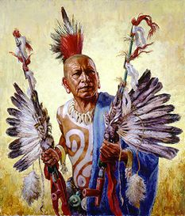

**Quapaw-** The Quapaws lived in eastern Arkansas and would be the first “discovered” by European explorers. Quapaw means “Downstream People,” but other people would call the tribe “the Arkansas.” They lived in the valley of the Arkansas River and were primarily farmers who, like the Caddo, grew squash, beans, and corn. They also hunted and fished. The houses were long rectangles with curved roofs made from wood and covered by bark and were usually shared by several families. The explorers who would encounter the Quapaw described them as tall and handsome people, who were friendly and peaceful.

**[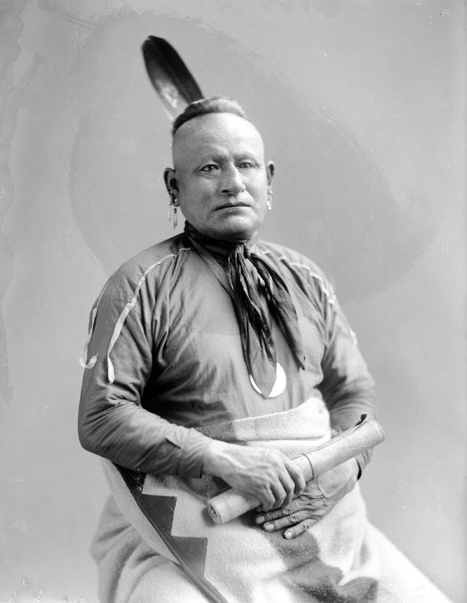](http://www.firstpeople.us/FP-Html-Pictures/American-Indians-GC10.html#Native_Photographs_5)**

**Osage**- This tribe did not actually live in Arkansas as their home villages were located in what is now southern Missouri. They did however consider what became north Arkansas as their hunting lands. Osage hunting parties sometimes attacked Caddo and Quapaw tribes and sometime after the 1700's, the Osage dominated the northwest part of Arkansas.

**European Explorers-** In 1542, Hernando de Soto was the first European explorer to enter what is today Arkansas. He was an explorer for Spain and was primarily seeking gold. De Soto’s party entered what became Arkansas, crossing the Mississippi near West Memphis, wandered around central Arkansas, and after the death of de Soto, left the state for the Gulf of Mexico.

One hundred and forty years later, Rene de La Salle explored and claimed the entire Mississippi River valley, including what was to become Arkansas for the French. He named the territory Louisiana after the King of France.

Henri de Tonti, a French explorer, established a trading post named Arkansas Post near the mouth of the Arkansas River, which was the state’s first permanent Euro-American settlement. De Tonti is often called “the Father of Arkansas.”

**United States Territory-** In 1803, the Louisiana territory, including what became Arkansas, was purchased from France by the newly independent United States. It more than doubled the size of the United States and President Jefferson was very interested in the exploration of the new territory. The Lewis and Clark expedition that explored the territory west to the Pacific Ocean is very well known, but a lesser known expedition was also commissioned by Jefferson. Although George Hunter and William Dunbar’s expedition was not as publicized as Lewis and Clark’s, their exploration of the Ouachita River in Arkansas and Louisiana was very important. For the first time explorers wrote detailed accounts of the Arkansas area using official studies and accurate scientific methods. Hunter and Dunbar were the first explorers to send Jefferson reports about the Louisiana Purchase. Hunter was trained as a medical doctor and Dunbar was a farmer, scientist, and diplomat. Their expertise and training in different areas was important to the success of the expedition.

**Early Settlement**

in 1803, Colonial Arkansas had perhaps 500 white inhabitants, most of them of French descent, living along the Mississippi River and the lower portions of the Arkansas and White rivers. Some of them were American citizens who had begun to trickle in during the 1790s, and their numbers increased when the land became part of the United States. The American settlement of Arkansas, however, did not begin in earnest until after the War of 1812. The Census of 1810 covered only eastern Arkansas, and there were some new settlers in the central and northern parts of the area, but the total white population and their small number of slaves was probably not much over the official count of 1,062 people.

The first significant American settlement of Arkansas came from the southeast portion of rapidly growing Missouri, where, by 1810, settlers were already moving down the Southwest Trail that ran diagonally from Cape Girardeau in Missouri across central Arkansas to the Red River in the southwest. Over the next decade, this migration increased and left settlements in the White and the Arkansas River valleys, various points on the upper Ouachita River and its tributaries, and in the Red River bottom land. As a result, the population center of Arkansas shifted well to the west of Arkansas Post, and the influence of the French settlers in the east rapidly declined. The growth was hardly spectacular, but in 1819, the Arkansas Territory was officially established. In 1821, the territorial government was moved from Arkansas Post to more centrally located Little Rock. The Census of 1820, which covered the entire territory (but excluded the Cherokee), found only 14,273 people. In 1830, there were 30,388.

Arkansas’s population grew rapidly during the 1830’s as massive numbers of Americans moved to all parts of the west. An 1835 census listed 52,240 people, and the number jumped to 97,974 in 1840. It doubled to 209,987 in 1850 and then doubled again to 435,450 in 1860. Nonetheless, in 1860 Arkansas still had only eight people per square mile and was barely out of its frontier stage. The early American immigration to Arkansas included large numbers of people from Kentucky and Tennessee, and those states continued to be important sources of settlers. With the growth of the cotton kingdom, however, an increasing number of new settlers came from the other southern states. In 1840, a majority of the white population of Arkansas lived in the highland areas of the north and west, but by 1860, about sixty percent were in the cotton-growing lowlands of the south and east.

**Statehood-** On June 15,1836, Arkansas became the 25th state to be admitted to the Union. In order for Arkansas to be admitted as a slave state, another state had to be admitted as a free state to maintain the balance between slave and free states. So Arkansas was admitted as the slave state, and Michigan was admitted as the free state. James Sevier Conway was elected the first governor of the state of Arkansas. Conway’s tenure as governor was a mixture of success and controversy. Under his administration, the state’s institutional structure took shape, including the banking system, the prison system, and an expanded network of public roads. With the Second Bank of the United States set to expire in 1836, Conway and other state leaders believed that it was crucial for the state to charter a bank that would furnish money and credit and serve as depository for surplus state funds. Two of the General Assembly’s first actions were bills to establish a State Bank and a Real Estate Bank. These bills were also among the first for Conway to sign into law.

**The Banking Crisis**

In 1937, the Real Estate and State banks were opened in Arkansas. The Real Estate Banks were mainly controlled by the planters who had large plantations, and only land served as collateral for the loans. Often the value of the land was worth less than the loan. The bank ran out of money and had to borrow from other states such as New York. The State Banks performed no better, and in two years had over $2 million in debt. Due to bad debts and corruption, both banks were forced to close. The State of Arkansas became legally responsible for the debt of the banks. Banks were consequently outlawed by the state and the state defaulted on the debts. The credit of the state was ruined and further funds for development were not available. This event negatively affected the state’s finances for decades to come.

**The Road to War**

In the 1850s, Arkansas was a frontier state. Most Arkansans, especially those who lived in the highlands of the north and west, were farmers engaged in subsistence agriculture on small parcels of land. In the fertile lands along the rivers of the state’s southern and eastern lowlands, however, a slave-based, plantation-style system of agriculture had developed. Cotton was the driving force behind the transformation from subsistence to plantation agriculture in this region. By 1850, Arkansas produced more than twenty-six million pounds of cotton, the majority of it in the Delta, and the expansion of cotton production seemed certain to continue throughout the next decade.

The growth of slavery in the state was directly linked to this expansion. By 1860, Arkansas was home to more than 110,000 slaves, and one in five white citizens was a slave owner. The majority of these held only a few slaves. Only twelve percent owned twenty or more slaves, the benchmark of “planter” status. But this small group of slave owners, most of whom lived in the southern and eastern lowlands, possessed a disproportionate share of the state’s wealth and political power.

**Arkansas and the Civil War**

Although Arkansas declined to join the other states that initially seceded from the Union, that situation was to change. On April 12, 1861, Confederate forces in Charleston, South Carolina, opened fire on the federal garrison at Fort Sumter in Charleston Harbor. Three days later, President Lincoln called for troops to suppress the rebellion, including 780 men from Arkansas. Arkansas was now reconsidered. The state convention reassembled in Little Rock, and the delegates voted overwhelmingly (the final vote was 69–1) for secession. At 4:00 pm. on May 6, 1861, Arkansas declared that it had severed its bond with the United States.

Initially, the majority of Arkansans supported the decision to secede, but a significant minority opposed the move from the beginning. The most serious challenge to the authority of the new Confederate state government arose in the mountainous regions of the north-central part of the state, where area residents formed a clandestine organization known as the Arkansas Peace Society. Local militias eventually broke up the society, but resistance to Confederate authority continued throughout the course of the war. Despite having the third smallest white population of any Confederate state, Arkansas supplied more troops for the Union army than any other Confederate state except Tennessee.

C:\Documents and Settings\amym\Local Settings\Temporary Internet Files\Content.IE5\ROQ0CVW2\MCj01495130000[1].wmfThe first full year of war seriously disrupted civil society in the state. Many local governments ceased to function and without law enforcement and a court system, crime became rampant. In southern Arkansas, many items—such as cotton cards, coffee, tea, and salt—had virtually disappeared. For the next two and a half years, many citizens of the state would experience the horrors of civil war to an extent matched by few other Americans, and the struggle for states’ rights and the southern way of life would quickly be overshadowed by the struggle for mere survival.

During 1861 and 1862 two important battles were fought in northwest Arkansas, the Battles of Pea Ridge and Prairie Grove. Both battles were fought primarily to secure Missouri for the Union and the Confederate forces failed in that quest. Further to the south in 1863 and 1864 the Confederates also had little success. In battles at Arkansas Post, Helena, Pine Bluff, and Little Rock the Union forces prevailed. With the fall of Little Rock, the capital was moved to Washington in southwest Arkansas for a short period of time.

The Civil War ended on April 9, 1865 when General Lee surrendered to General Grant at Appomattox Courthouse, VA. The Civil War was one of the greatest disasters in Arkansas history. More than 10,000 Arkansans—black and white, Union and Confederate—lost their lives. Thousands of others were wounded. Devastation was widespread and property losses ran into the millions of dollars. The war left a legacy of bitterness that the passage of many years would not erase.