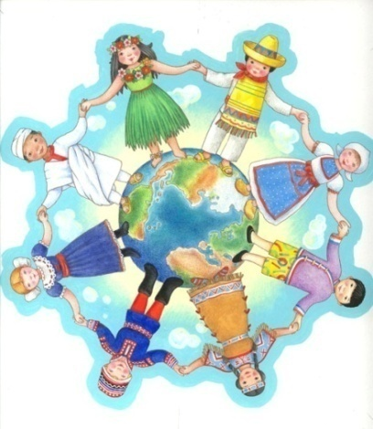
By: Dr. Rita Littrell

Children of the World:
Research Activity

FOCUS:

Overview:
Children of the world have many similarities. They all want to have a safe home with love and support from their family. They need food, clothing and shelter. There are many similarities and many differences in how their needs are met. Through this activity students will work in groups of two to learn about children from each of six continents. Through location of their home countries and identification of natural resources they will practice geography. As they explore the uses of the resources to provide their basic needs students will learn economics. Many children of the world face daily scarcities that cannot be comprehended by children from the industrialized world. Though these are not emphasized in the book, students will begin to understand that not all children have the same opportunities. Students see that life around the globe may differ from theirs. Through basic research and comparison of the children in the book students learn of the similarities and diversity of the world’s children. They use a Venn Diagram to compare the lives of two children. Each child ‘adopts’ a friend and then plays a game using the information learned about their friend. The source for the research is Children Just Like Me by Barnabas and Anabel Kindersley; DK Publishing, Inc.; ISBN 0-7894-0201-7.

Objectives:
Students will:
- Learn about wants of children around the globe
- Learn how natural resources are used for food, clothing and shelter
- Learn about the lifestyle of children from other countries
- Identify the countries of the children researched
- Adopt a friend based on their research

Time Required
2 class periods

Grade Levels
Third (with modifications) through eighth

Vocabulary/National Economic Content Standards
Students will understand that:
Productive resources are limited. Therefore, people cannot have all the goods and services they want; as a result, they must choose some things and give up others.
People make choices because they can't have everything they want.
Economic wants are desires that can be satisfied by consuming a good, service, or leisure activity. People's choices about what goods and services to buy and consume determine how resources will be used. People whose wants are satisfied by using goods and services are called consumers.
Productive resources are the natural resources, human resources, and capital goods available to make goods and services.
Natural resources, such as land, are "gifts of nature;" they are present without human intervention.
Human resources are the quantity and quality of human effort directed toward producing goods and services.
Capital goods are goods that are produced and used to make other goods and services.
People who make goods and provide services are called producers.

PREPARE:

Materials:
Book Children of the World (see information above)
Handout 1 – World Map
Handout 3 – Lifestyle Comparison Grid
Handout 2 – Culture Summary Page
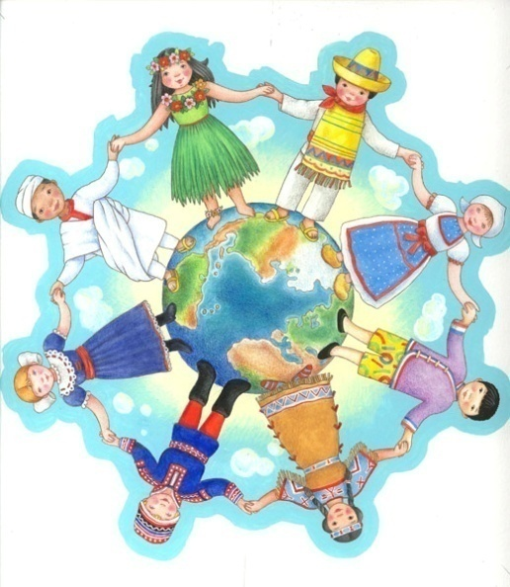
Handout 4: Venn Diagram- Similarities among Children of the World
Sheet of construction paper for each child in the class

Construct:
Activity 1
- Copy Handout 1: World Map for each group
- One copy per group of Handout 3: Lifestyle Comparison
- Six copies per group of Handout 2: Culture Summary Page
Activity 2
- One copy per group of Handout 4: Similarities among Children of the World
- Place the sheets of construction paper on the floor or ground in a large circle. You should have one per student.

TEACH:

Introduction:
- Have students discuss any travel experiences to other countries or friends they have made from these countries.
- Ask them if all children live in houses similar to theirs. Draw a picture of a typical local house on the board with suggestions from the students.
- Ask why our houses are built of brick and wood.
- List the typical foods that our children eat on the board.
- Discuss if this is what children of the world eat.

Activity 1:
- Assign students to groups of two. They are research partners. Explain that they will work together to learn about children of the world.
- Either have students choose one child from each continent or assign them. (Narrow the research to fewer children if you have tight time constraints.) If you do not have enough books for students to complete activity at the same time you may want to have the groups rotate through the activity or you can copy the pages needed for each group. (Note: The book has children grouped in the Americas rather than North and South America.)
- Have students read the information about the children to which they have been assigned. For each child researched have them complete Handout 2: Culture Summary.
- Once they have read the summaries for each child and completed the Culture Summary handout, have students summarize the information on the table provided - Handout 3: Lifestyle Comparison.
- Once the students have completed their research, discuss which child they would like to meet with their rationale. Explain that this is their ‘adopted’ friend. They must learn a lot about their friend.

Activity 2:
- Use Handout 4: Similarities among Children of the World to review the information about the two children. Have each student in the team select or ‘adopt’ a friend from their research. Have them complete the Venn diagram based on the two friends selected.
- Have students form a large circle in the room, playground or other space. Explain that you will make a statement. If it is true for the life of the child’s friend then the student must trade places. Before beginning, remove one square of paper.
- Read one of the following statements. If it is true for the student’s ‘adopted’ friend, s/he should change places with another student by running across the circle to a new spot. If left in the center without a spot the student must share something interesting about the adopted friend.
- Statements: Change places if
- Your child’s house is made of mud.
- Your child has a pet
- Your child eats rice
- Your child lives in Africa
- Your child lives on an island
- Your child’s family raises cows
- Your child’s family owns goats
- Your child lives in a warm climate
- You can’t read your child’s handwriting
- This activity should help students to recognize the similarities and diversity of the world’s children.
- Leave book on display in the room for students to read and learn about other children of the world.
- Optional Extension: Have the students’ use the Internet (www.Heifer.org) or Heifer gift catalogs to determine what type of gift animal would be good to give to poor families of children from the ‘adopted’ countries.

Closure:
- Discuss similarities among the children of the world. Discuss any concerns noted from the research. Discuss things the students found interesting from their research.
- Emphasize that because someone lives in different houses, has different beliefs, looks different, has a different language or is different in anyway does not make that person or their beliefs BAD. It just makes the different. Sometimes we might want to adopt ideas, beliefs or practices from others once we have learned them.
- As an example share that Mexican families meet at 2:00 for lunch everyday. The entire family comes home and eats the noon meal together. Note that this type of practice strengthens family ties and might be of benefit to many around the world. Having a safe and healthy family filled with love is a shared desire of all children.

Connect:

Graphing:
Graph of global livestock usage: Have students create a graph of the types of livestock that are most commonly used by a children from the countries studied. This can be done by giving students one 2” x 3” piece of paper for each country researched. Each team will place their square in the appropriate space creating a bar graph showing livestock usage.

Graph of employment: using the same procedure as above, graph the type of employment for the parents. You would need to give two pieces of paper to most students since most families have two parents. Categories can include manufacturing, education, service, home production, the arts, and unemployed.
Education Attainment: Repeat the procedure from above with each student graphing the level of education of the parents. Categories would include primary school, secondary school, advanced training, college, or post-graduate. Students will need to guess about the education levels but it will serve as a tool to encourage them to make the connection between education and job opportunities.

Art:
Have students create a picture of their ‘adopted’ friend. Using a world map on a bulletin board place the faces on the countries of the children.

Writing:
Have children write a letter to their friend describing their lives in a similar fashion to the book.

As a way to help students reflect on their life, have them journal all of their activities for two days.

Internet:
Have student go to the following website to learn about breakfast for children of the world. This is a short Webquest with an interactive activity.
http://www.econedlink.org/lessons/index.cfm?lesson=EM41&page=teacher

Arkansas Social Studies Frameworks & Benchmarks:

8. Resources
Students shall evaluate the use and allocation of human, natural,
and capital resources.
E.8.2.3
Discuss the availability of natural resources

E.8.3.3
Recognize the product associated with the natural resources from which it is created
E.9.K.4
Recognize that people choose among a variety of goods and services
E.9.K.5
Recognize that people work to earn money to purchase items
E.9.3.4
Identify and explain the role of each productive resource in producing a good or service
(e.g., school lunches)

E.8.6.3
Explain how owners of the factors of production receive payments for the use of these factors:
- wages and salaries
- rent
- interest
- profit

Handout 1: World Map

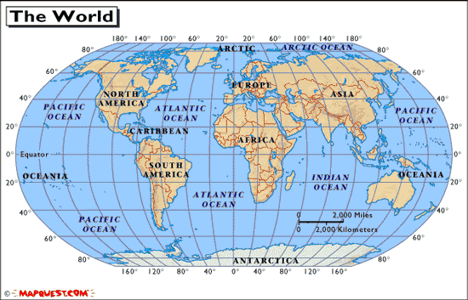
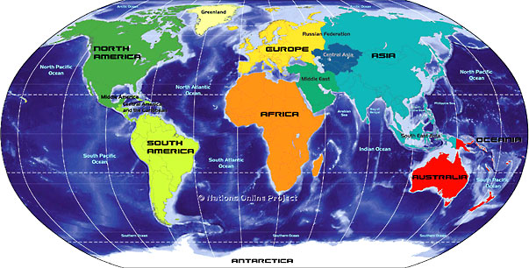
Handout 3: Lifestyle Comparison Table

Country/Child | Climate | Natural Resources | Foods | Clothing | Shelter | Toys/hobbies | Pets | School
North America:

South America:

Australia:

Europe:

Africa:

Asia:

Handout 4: Venn Diagram – Similarities among the World’s Children

Child: Child:
Handout 2: Culture Summary Page

For each child researched complete this information:

Name of Child:

City: Country: Continent:

Language: Religion:

- Climate:

- Parents’ employment:

- Types of livestock and uses:
- Describe their housing and use of materials:
- What are typical foods?
- Describe their clothing including the materials used.
- What type of pets do they keep?
- Describe their toys or hobbies.
- Describe their school building.
10) Anything interesting.

Heifer Gift recommended with rationale: (Use Heifer gift catalog or www.heifer.org)

